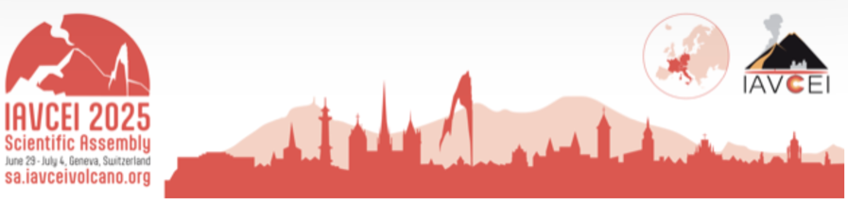

Early-career researcher plenary session application

We are happy to announce that there will be TWO opportunities to showcase Early Career Researchers (ECRs) and their work at the IAVCEI Scientific Assembly 2025! The ECR plenary session is new to IAVCEI and was first implemented during the 2023 IAVCEI Scientific Assembly meeting with a resounding success. For the upcoming conference, we continue this new tradition and add even more time for ECRs to highlight their research in a special dedicated session.

The first opportunity: Plenary Session
In addition to the typical senior plenary sessions, a half-hour session will also be held each day to showcase excellent early-career researchers. One researcher will showcase their work in each half-hour session. There will be a total of 4 ECR plenary speakers throughout the week. The proposed topic should be in addition to an abstract submission and should be broader in scope than a typical conference presentation. We are particularly interested in topics that complement the senior plenary presentations (listed below), though presentations on all volcanological topics are welcome!
- Recent unrest at Taal Volcano, Philippines; insights from a complex geological and social environment (Mariton Bornas)
- The laws of magma propagation by diking and what we can learn about volcanoes by applying them (Eleonora Rivalta)
- Minerals, fluids, metals and mining – what might the future of resourcing a sustainable world look like? (Richard Herrington)
- The dynamics of volcano-hydrothermal systems - hazards, energy and mineral resources, and extreme forms of life (Shaul Hurwitz)

The second opportunity: The Future of Volcanology
In addition to the plenary sessions, there will also be a 30-minute session each day titled “Theme 8: The Future of Volcanology”. This is an excellent opportunity for ECRs to discuss how they push the boundaries of our current understanding of volcanology with their research and what the future of volcanology may look like! In this session, we invite applications for two 15-minute presentations each day, for a total of 8 speakers throughout the week.

For both of these opportunities, the researcher must have a PhD and be within 8 years of finishing their PhD or hold a professional job and have less than 8 years of professional volcano-related research experience. This time does not include parental or other relevant leave, with the 8 years counted up to 2025. We particularly encourage applications from historically under-represented groups. Please note that you must be attending in person to be considered and consider applying for travel support grants (https://sa2025.iavceivolcano.org/travel-grants/).
Applications are DUE on January 10th, 2025 and should be submitted via email to Alex Iezzi at aiezzi@usgs.gov, Sandy Drymoni at kyriaki.drymoni@min.uni-muenchen.de, and/or Joali Paredes-Mariño at joa.paredes.marino@auckland.ac.nz.

If you want to apply to both session types, please submit two applications. A person can give a talk in a maximum of one of these sessions, which will be decided by the selection committee.

We ask for:
- Completion of the self-nomination application form which includes a summary of the intended topic, a list of supporting lead-author papers, and a motivation statement on why you should be chosen.
- A short CV (max. 2 pages) including your education and employment history.

The review process will take into consideration the following points:
- Significance of your research
- Novelty of your proposed talk
- Application and communication of your research with the wider community
The review panel will also ensure that there is a gender, topic, and nationality balance in the speakers chosen.

For any questions about the ECR plenary session and application process please email Alex Iezzi at aiezzi@usgs.gov, Sandy Drymoni at kyriaki.drymoni@min.uni-muenchen.de, and/or Joali Paredes-Mariño at joa.paredes.marino@auckland.ac.nz.

Early-career researcher plenary session application

Your name

Are you post-PhD and are within 8 years (up to 2025) of your completing your PhD not including parental or other relevant leave? Or are a professional who has a maximum of 8 years professional volcano-related research experience? | Yes/No

Email

Which presentation type are you applying for?
Plenary session (30 min) or Theme 8: Future of Volcanology (15 min):
Title of your proposed presentation:

Briefly describe what you would cover in your presentation (max 200 words)

List supporting lead-author publications or reports

Motivation statement (For example, why do you believe this opportunity would benefit you, the wider volcano community, and/or society in general?)

Any other notable contributions to the research/science community? (Not essential)

Please keep this form to 2 pages max. Please also attach a short CV (max. 2 pages) with this form. Your CV should include your education and employment history.

